**SMART PATROLLING ROBOT**

**M.S.S.S Karthikeya , M. Prem Sainath , M. Sathvik Reddy , P. Sai Sharad Chandra**

**Department of Computer Science-Internet of Things**

**VNR Vignana Jyothi Institute of Engineering and Technology**

**ABSTRACT**

Around the world, there is a lot of concern about the safety and welfare of people. Despite living in a technologically advanced world, crime rates are gradually increasing, as we have all witnessed. The patrolling robot aims to tackle this issue. Our system uses ultrasonic sensors to detect distance from objects and avoid them. The ultrasonic sensor attached to a servo motor detects the distances between objects and chooses the path with the longest distance. The proposed system use an ESP32 Ai-Thinker camera. The video recorded by it is live streamed to a specific IP- address. The proposed system can monitor the livestream with the IP-address.

**I.INTRODUCTION**

The security requirements of each element in the IoT ecosystem vary according to different applications. As a result, the security solutions also vary accordingly , Security is one of the primary issues that every organization will deal with. Employing security guards to keep an eye on the area one is in is the first answer that most people in this circumstance consider, but this is very expensive and takes a lot of staff[1]. The task of night time monitoring has recently proven to be particularly difficult. There are a few places where viewers are unable to concentrate. A robot that can recognise trespassers in the area, such as workplaces, homes, buildings, and so on, and report them to the nearby board security control unit is a basic requirement in this situation[2]. A late-night guarding robot is developed in the current work with improved ability to recognise and warn if there is any human activity in the area to provide a precise observation framework[3]. While being observed, the robotic Night Patrolling vehicle travels in a random path. The system uses a UV sensor-based way-following framework to keep an eye on the designated area. In order to prevent a collision, a robot's development is also controlled in this way by deterrent recognising sensors[4]. The robot's top-mounted camera captures images, records videos, and sends them to the client as it scans each area for signs of disruption. Additionally, the client may receive the live video signals from the system. The main objective of this system is to identify questionable activities in areas where people cannot be observed.

**II.LITERATURE SURVEY**

A Surveillance System Using Arduino's Internet Protocol was built, in which the Arduino and the internet protocol were utilised to build a surveillance system using a night patrolling robot [1]. It talks about several methods of night-time surveillance. Most areas are patrolled by the police at night , but even then, it is hard to find every tiny accident in the middle of the night. As a result, it's necessary to have a device that can monitor this area for activity and alert the local security control unit [2]. The Arduino operating system and a remote monitoring and control algorithm are used to construct a patrolling robot. Three parts make up the spy robot device: an Arduino module, a night vision camera, and an ultrasonic sensor. The system needs an Arduino, which is comparatively less expensive, to operate. If process control is made possible by using low-cost microcontrollers, it will be affordable for everyone to develop a mobile robot using GPS and a place recognition algorithm[3]. This work proposes a survey of a mobile robot with live camera feed. The system can yet be enhanced to deliver outputs with a high degree of precision and reliability [4]. This project generates a variety of concepts for both monitor tracking and road surveillance. Road and street monitoring is essential for a number of activities, such as identifying pedestrians and spotting suspicious activity.. By including an obstacle-sensing feature and a system that uploads the live feed of the camera to the designated ip address, the system's efficiency can be increased even more. The system can yet be improved to produce results with a high level of accuracy and dependability[5]. This approach classifies the pixels in the road image. The system's effectiveness can be further improved by adding a barrier feature and a Communication unit that shares its location. Deep data processing skills and picture acquisition tools are used to enable real-time facial expression recognition [6][7][8]. This robot's main objective is to monitor human activity in zones which have less surveillance and can be a potential zone for illegal activities [9]. To boost the system's effectiveness, the quality of the camera feed can be increased. This paper's main goal is to develop and construct a surveillance robot that can stop odd actions. The robot serves as a surveillance robot, recording the suspicious person's surroundings up until the point at when the authorities are notified. The technology could be improved to deliver alert notifications. As a result, the proposed method is created to address some of the aforementioned issues.

**III.METHODOLOGY**

The proposed methodology of the system is to be involved in patrolling in assigned areas and to function with least human intervention with the help of its features. Since it needs to move without colliding with objects in its path while moving it is provided with an ultrasonic sensor for obstacle sensing. To live stream the video it captures video from ESP32 Cam Module.. While interfacing the robot with a user device IoT has done its vital role. The block diagram ,circuit diagram and flowchart for the paper shown below

**3.1. Proposed design**

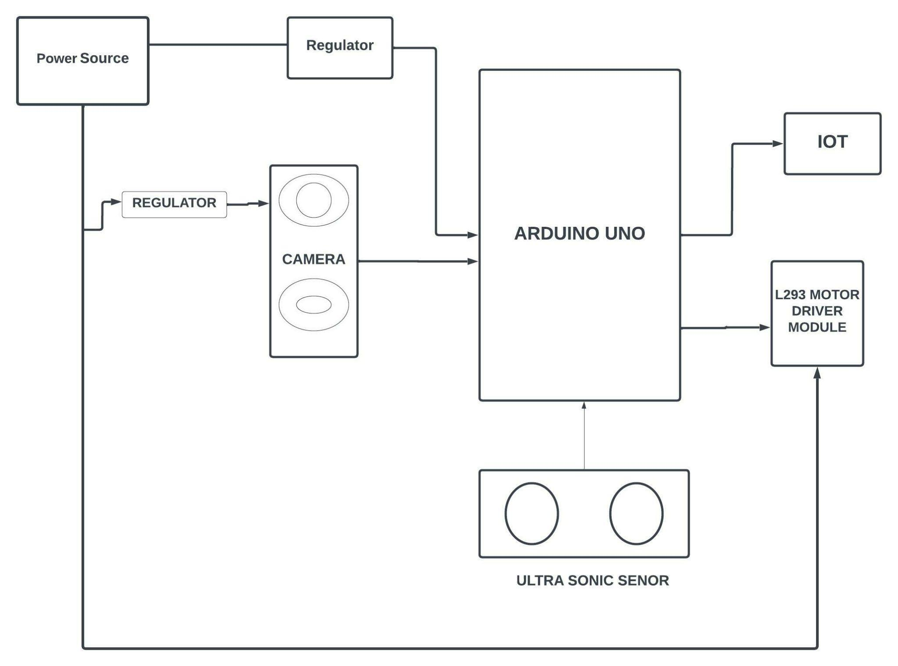

**Fig 1.a. Block Diagram of night patrolling system**

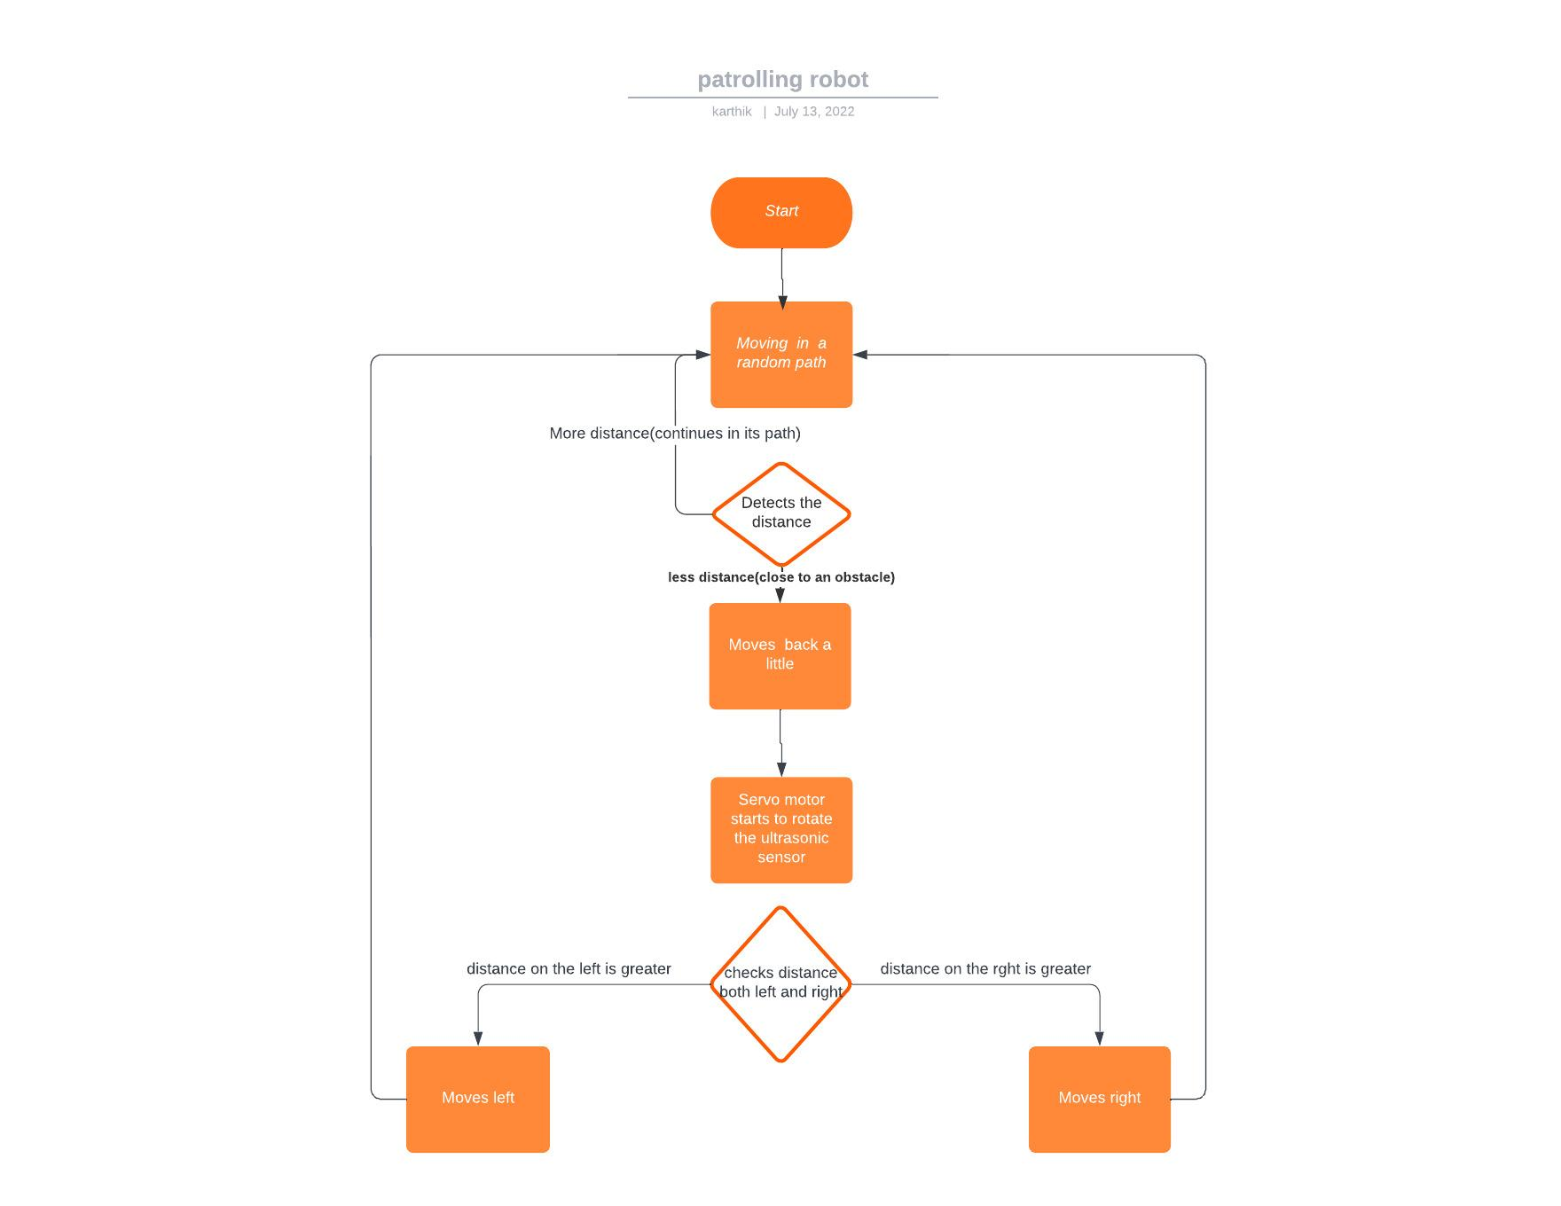

**Fig 1.b. Flow chart for the proposed system**

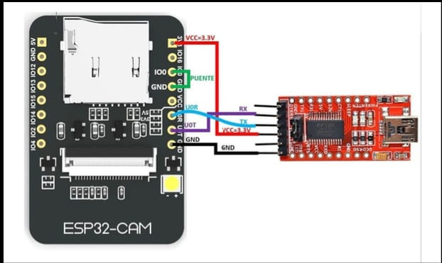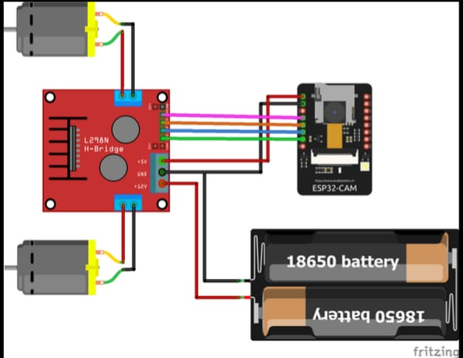

**Fig 1.c. Circuit Diagram**

**3.2 Working**

We will be using an Arduino UNO microcontroller to control the functioning of the robot.The robot will be utilising the Arduino L293D motor driver shield for its movement and mobility which is connected to the Arduino UNO microcontroller. An ESP32 Cam Wi-Fi Bluetooth Development Board will be used for camera usage and live streaming the camera feed to a designated ip address. The robot also uses HC-SR04 Ultrasonic sensors to detect the distance between the robot and the obstacle. The ultrasonic sensor and the camera together are fitted with a MG996R Servo Motor which is connected to the Arduino motor shield, which enables the rotation of both the camera and the ultrasonic sensor together . The robot initially moves forward until it encounters an object. When the distance between the robot and the obstacle reaches a minimum limit the robot reverses its movement and goes backwards . After going backwards , the robot then checks the distance to its left side and right side by rotating the ultrasonic sensor using the servo motor . The robot then turns to the side where the distance is minimum, which is to the left or right and then moves forward. The camera feed is live streamed throughout the entire process. The inputs to the wheels connected to the motor driver shield ,at pins M3 and M4 ,are given below in table fig.3.

|  |  |  |
| --- | --- | --- |
| **Movement** | **M3** | **M4** |
| Forward | 1 | 1 |
| Backward | 0 | 0 |
| Right | 1 | 0 |
| Left | 0 | 1 |

**Fig.2 Movement and respective input to pins**

**3.3 Hardware Components**

a)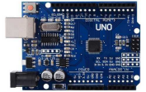 b) 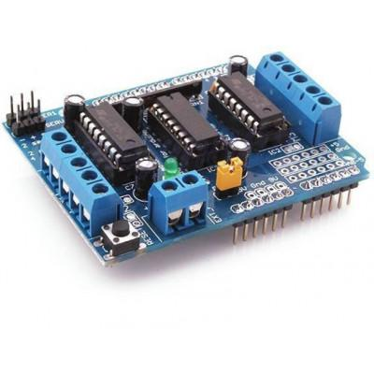

c)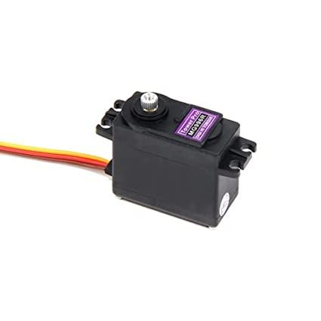 d)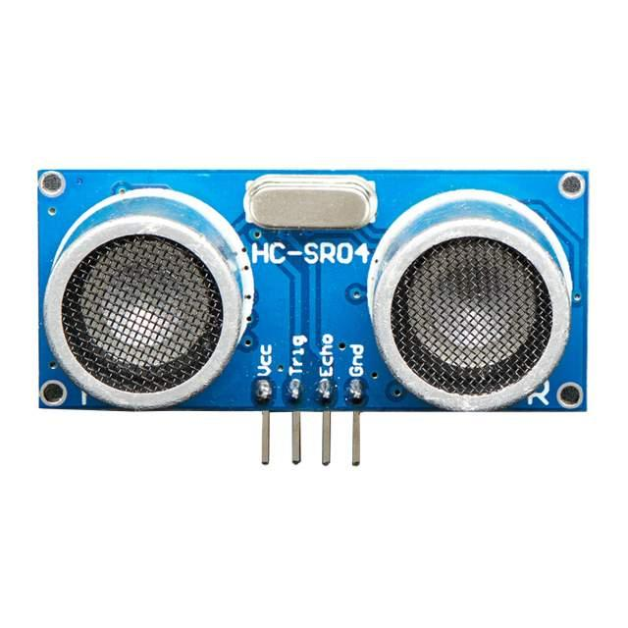 e)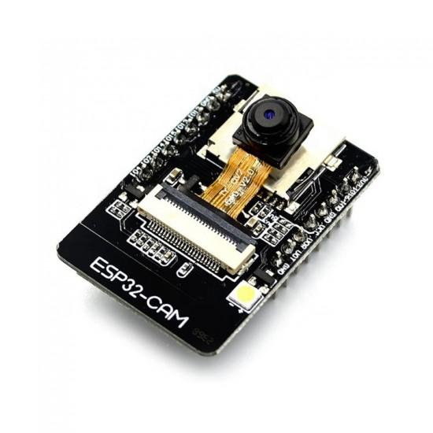

**a.Arduino Uno:**  The Arduino UNO is an open-source microcontroller based on the ATmega328P. It has 14 digital input/output pins out of which 6 can be used .

**b.L293D Motor Driver Shield:**Two servo and four motor connectors for DC or stepper motors are provided on the L293D Motor Driver Shield for Arduino.

**c.MG996R Servo Motor:**

The MG996R is ametal gear servo motor with a maximum stall torque of 11 kg/cm. Like other RC servos the motor rotates from 0 to 180 degree based on the duty cycle of the PWM wave supplied to its signal pin.

**d.HC-SR04 Ultrasonic Sensor:**

The ultrasonic sensor, often known as a transducer, operates similarly to a radar system. Electrical energy can be transformed into acoustic waves by an ultrasonic sensor, and the other way around .Ultrasonic sensor detects the distance between itself and other objects. It has two main parts - echo and trigger

**e.ESP32 Cam Wi-Fi Bluetooth Development Board:**

The ESP32-CAM is an ESP32-based, compact camera module with low power requirements. It features an on-board TF card slot and an OV2640 camera. Numerous clever IoT applications, including remote  monitoring, Wi-Fi picture sharing, QR authentication, and others can make use of the ESP32-CAM.

**IV.RESULTS**

Proposed system consists of an ESP32 camera for live streaming and a UV sensor coupled to a servo motor. When an impediment or obstacle is detected within the frequency range by the UV sensor attached to the board, it checks side views, takes measurements, and then travels accordingly to the right, left, forward, or rearward as necessary.

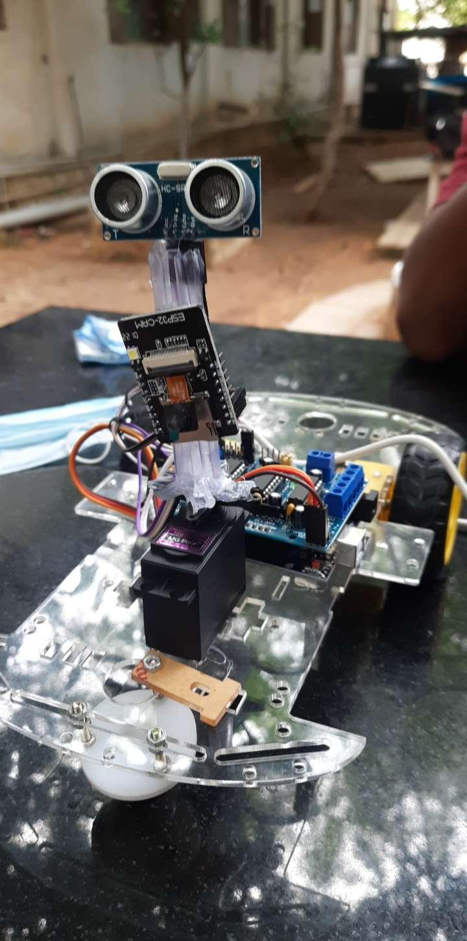

**Fig 4.1. Robot view**

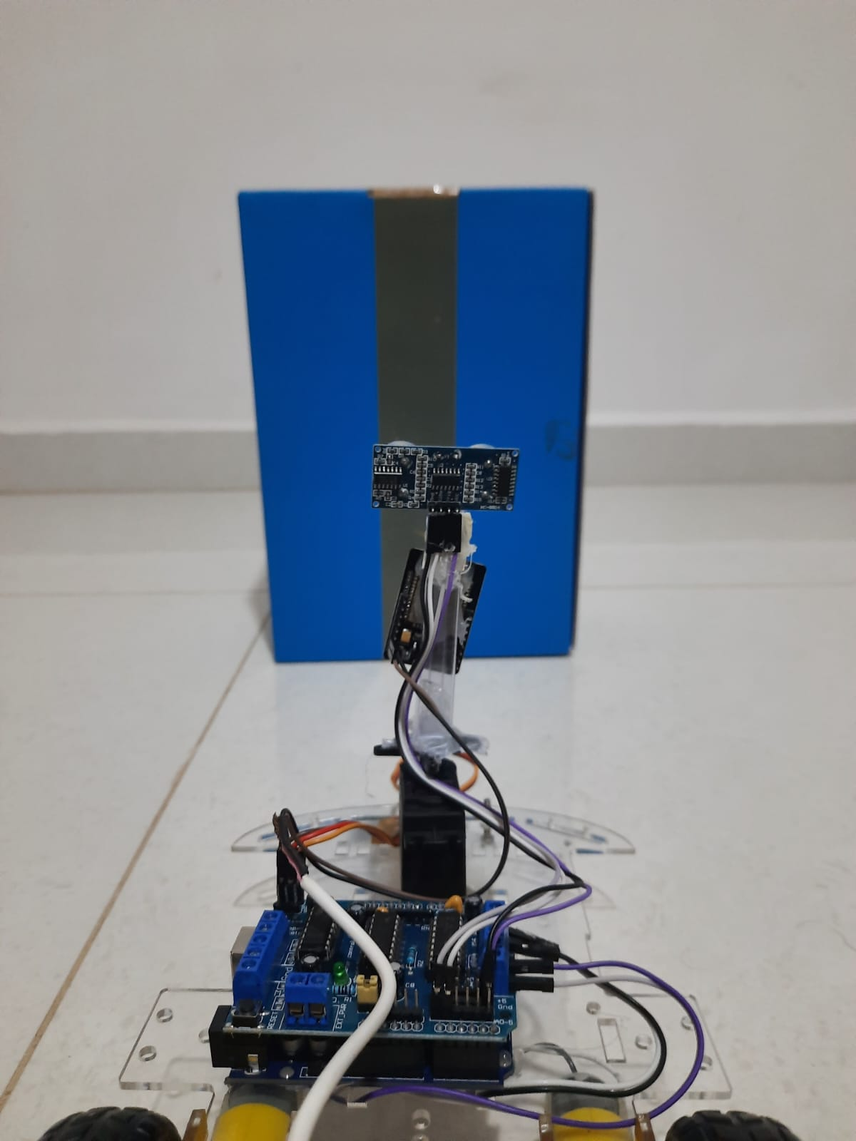 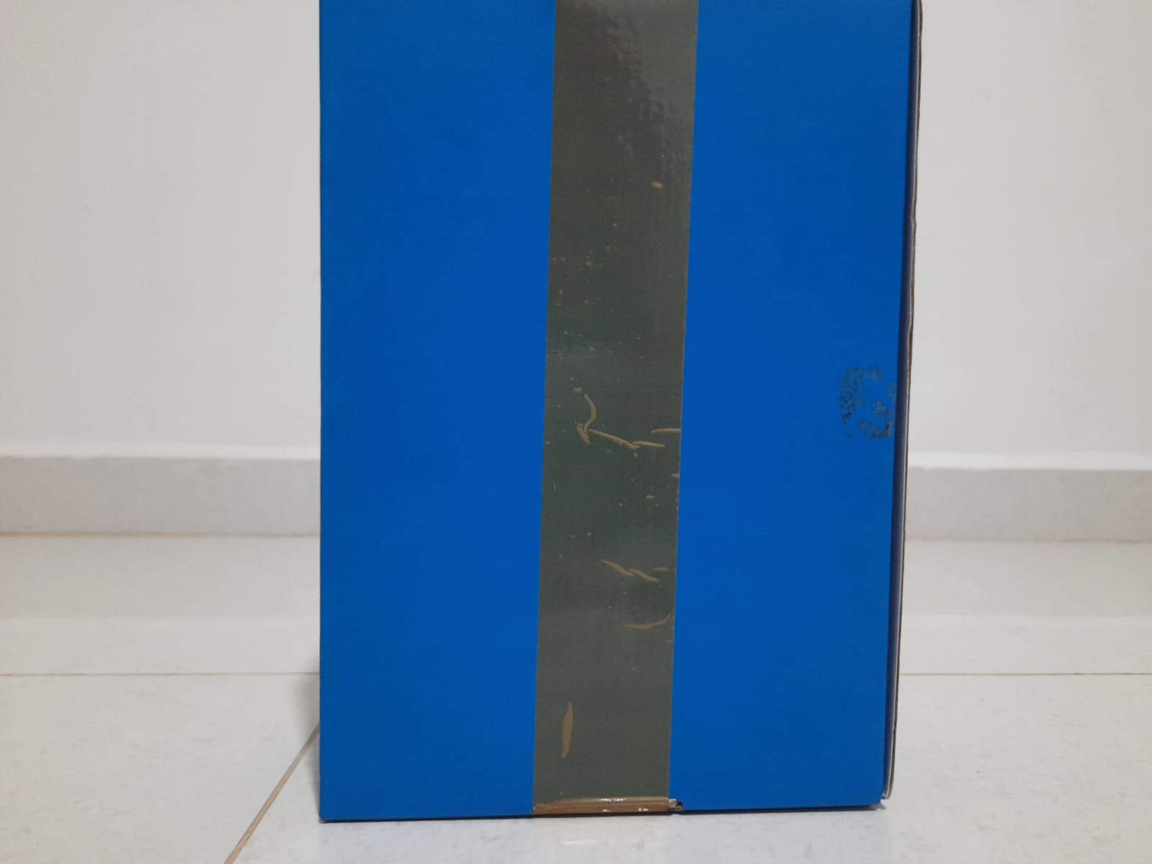

**Fig 4.2 Obstacle detected Fig 4.3 Camera view of the obstacle**

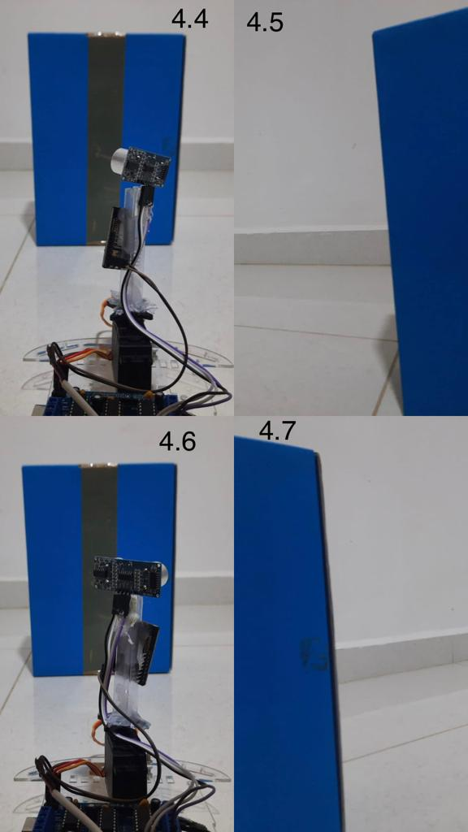

**fig 4.4Inspecting Left side, fig 4.5 Camera view of left side, fig 4.6 Inspecting Right side, fig 4.7 Camera view of right side**

**V.CONCLUSION**

This paper concludes with a night patrolling safety robot, which uses ultrasonic sensors. The robot moves in the same direction until it encounters an object. When it encounters an object, Directly to the display room for further action, it gathers and transfers the images. This device claims that the entire area is monitored using night vision cameras and that it is able capture the live video of the area where the information can be kept or the video can be live streamed. Since the webcam used is a night vision camera, the security system will benefit from streaming video using IoT. This device provides automatic intelligence for night-time patrol.

The Internet of Things is a new paradigm that offers customers a variety of chances with affordable, effective applications and services. But one of the main objections to a wider adoption of IoT technologies is security. If a proper evaluation of potential risks and assaults doesn't fulfil the necessary security criteria, an IoT device will be exposed to attacks. In this work, we analyse the issues raised by the lack of IoT architecture standards. When implementing security and design, systematic techniques that see IoT systems as an entire ecosystem offer more flexibility. As a result, using the four-layered IoT architecture that was developed, we methodically combined important risks and attacks on critical components of an IoT ecosystem. We conclude by talking about the crucial security standards that are essential explicitly advanced for IoT systems, which will help researchers in IoT security to innovate new and improved security solutions.

**VI.REFERENCES**

[1]. Kouicem DE, Bouabdallah A, Lakhlef H. Internet of things security: A top-down survey. Comput Netw 2018; 141:199–221.

[2]. Arias, Orlando, et al. "Privacy and security in internet of things and wearable devices." IEEE Transactions on Multi-Scale Computing Systems 1.2 (2015): 99-109.

[3]. George, Remya, et al. "An intelligent security system for violence in public places." International Journal of Engineering and Advanced Technology 3.4 (2014).

[4]. Helen, A., et al. "A smart device for security based on iot concept „watch me‟." 2017 2nd International Conference on Computing and Communications Technologies (ICCCT). IEEE, 2017.

[5]. Hyndavi, V., N. Sai Nikhita, and S. Rakesh. "Smart wearable device for safety using IoT." 2020 5th International Conference on Communication and Electronics Systems (ICCES). IEEE, 2020.

[6]. Jain, R. A., et al. "People’s safety using IOT" International Research Journal of Engineering and Technology (IRJET) 4.05 (2017): 2336-2338.

[7]. Miriyala Geetha Pratyusha, et al. "Smart intelligent security system." International Journal of Electronics and Communication Engineering & Technology (IJECET) 7.2 (2016): 41-46.

[8]. Nguyen, Hung, et al. "Using inertial sensors to automatically detect and segment activities of daily living in people with Parkinson’s disease." IEEE Transactions on Neural Systems and Rehabilitation Engineering 26.1 (2017): 197-204.

[9]. Paradkar, Abhijit, and Deepak Sharma. "All in one intelligent safety system for security." International journal of computer applications 130.11 (2015): 33-40.

[10]. Sharma, S., Ayaz, F., Sharma, R., Jain, D. and Student, B.E. “IoT Based Safety Device using ESP32.” IJESC, 7(5) (2017): 11465-11466.

[11]. Thavil, J. K., V. P. Durdhawale, and P. S. Elake. "Study on Smart Security Technology based on IOT." International Research Journal of Engineering and Technology (IRJET) 4.02 (2017).

[12]. Thiyagarajan, M., and Chaitanya Raveendra. "Integration in the physical world in IoT." 2015 International Conference on Green Computing and Internet of Things (ICGCIoT). IEEE, 2015.

[13]. Ziegeldorf, Jan Henrik, Oscar Garcia Morchon, and Klaus Wehrle. "Privacy in the Internet of Things: threats and challenges." Security and Communication Networks 7.12 (2014): 2728-2742.

[14]. K. Labayrade, J.P. and D. Aubert In Intelligent Vehicle Symposium, 2002, Tarel, Real Time Obstacle Detection in stereovision on non flat road geometry by disparity representation. IEEE. IEEE, vol. 2002 2, 646 651 pp.

[15]. “Review of human detection techniques in night vision” in 2017 International Conference on Wireless Communications, Signal Processing and Networking (WiSPNET) .